FloodSense Initial Survey Results and Summary
Flood Information and Pre-Event Preparedness Needs of Bacoor City Residents
Descriptive analysis of 40 qualified respondents
Survey responses collected on 11 October 2026

This report presents the complete descriptive results, integrated interpretation, research implications, and limitations of the FloodSense initial resident survey.

Executive Summary
All 40 submissions met the survey's consent and eligibility requirements: every respondent consented, was at least 18 years old, lived in Bacoor City, and reported a flood or heavy-rainfall experience within the survey reference period. The results provide strong descriptive evidence of information-access and preparedness difficulties among this respondent group, but they do not establish citywide prevalence or prove the effectiveness of FloodSense before post-use evaluation.
The clearest problem signal is the difficulty of obtaining adequate flood information. A total of 29 respondents (72.5%) described obtaining needed information as difficult, very difficult, or usually impossible. In addition, 30 respondents (75.0%) said late, unclear, incomplete, or conflicting information often or always affected their decisions. All eight assessed information problems received mean frequency scores within the 'Often' range.
Existing channels are widely used, especially official Bacoor City or BDRRMO social-media pages, Facebook groups, news outlets, SMS, PAGASA or other agencies, and personal networks. Their continued use alongside high levels of reported difficulty supports the conclusion that the issue is not simply the absence of information. Respondents reported gaps in timeliness, clarity, consistency, accessibility, source transparency, location specificity, preparedness guidance, and verified evacuation-center information.
The sample also indicates practical feasibility for an Android-based supplementary tool: 39 respondents (97.5%) reported regular access to their own or a shared Android device, while 29 (72.5%) described their internet access during heavy rainfall as always or usually reliable. Most respondents preferred bilingual English and Filipino presentation. Manual barangay selection, a temporary map pin, and one-time GPS access all received substantial acceptance.
The evidence supports a focused role for FloodSense as a supplementary, scenario-based pre-event decision-support application. The findings can justify location-specific susceptibility assessment, explainable results, map-based location selection, scenario-relevant preparedness guidance, and verified evacuation-center references. They do not justify claims of live flood forecasting, automatic warnings, real-time water-level monitoring, road-safety guidance, safe-route recommendation, live center availability, or official evacuation orders.

Key Findings
- 30 respondents (75.0%) reported more than five flood or heavy-rainfall events within the three-year reference period.
- 29 respondents (72.5%) reported difficulty obtaining needed flood information or usually could not obtain it.
- 30 respondents (75.0%) said inadequate information often or always affected decisions.
- 30 respondents (75.0%) found it difficult, very difficult, or did not know how to determine whether their location might be susceptible to flooding.
- 33 respondents (82.5%) found verified evacuation-center information difficult to find or did not know where to find it.
- 39 respondents (97.5%) had regular access to an Android smartphone through their own or a shared device.
- The sample covered 14 barangays, but 28 respondents (70.0%) came from Niog or the three Zapote barangays.

1 Survey Scope and Method

1.1 Purpose
The initial resident survey was designed to identify current flood-information problems, their effects on household preparedness and decision-making, the information residents find difficult to obtain, and the feasibility requirements for an Android-based supplementary information tool. It was not a post-use evaluation of FloodSense.

1.2 Respondent Eligibility and Data Collection
The workbook contained 40 completed submissions collected on 11 October 2026. Eligibility required informed consent, an age of at least 18 years, current residence in Bacoor City, and experience of flooding or heavy rainfall that affected the household, community, travel, work, or studies during the stated three-year reference period. All 40 submissions met these conditions.
Eligibility requirement | Qualified respondents | Percentage
Provided informed consent | 40 | 100.0%
At least 18 years old | 40 | 100.0%
Current Bacoor City resident | 40 | 100.0%
Experienced flood or heavy-rainfall effects | 40 | 100.0%

1.3 Analytical Method
The report uses descriptive statistics. Single-response questions are summarized with frequencies and percentages. Checkbox questions use the number of respondents selecting each option, divided by 40; because a respondent could select more than one option, percentages for a checkbox question can total more than 100%.
For the eight frequency statements about existing information problems, responses were weighted as Never = 1, Rarely = 2, Sometimes = 3, Often = 4, and Always = 5. 'Not sure' responses were excluded only from the mean calculation and remain visible in the frequency tables. Mean ranges were interpreted as follows: 1.00-1.80 Never, 1.81-2.60 Rarely, 2.61-3.40 Sometimes, 3.41-4.20 Often, and 4.21-5.00 Always.
The optional name or initials field was completed by 35 respondents (87.5%). Names and initials were excluded from every analysis, table, chart, and narrative in this report.

1.4 Data-Quality Review and Limitations
The results should be interpreted as evidence about the surveyed group, not as population estimates for all Bacoor residents. The study used a small purposive sample and did not use probability sampling or inferential statistical tests.
- Geographic coverage included 14 of Bacoor's 47 barangays. Niog and Zapote 1, Zapote 2, and Zapote 3 accounted for 70.0% of the sample.
- Respondents aged 18-34 accounted for 30 of 40 responses (75.0%).
- The three-year recall period increases coverage of flood experience but may introduce recall error about the timing and details of older events.
- One pair of submissions had identical answers across all substantive fields after excluding timestamp and optional name. The submissions were retained because independence could not be determined from the workbook alone.
- Five consecutive submissions occurred less than ten seconds apart. This timing cluster does not prove invalidity, but it should be considered when assessing response independence.
- Six optional comments repeated the same long recommendation word for word. Closed-ended responses were counted as submitted, while qualitative interpretation reports the repetition explicitly rather than treating it as six independent ideas.
- A few checkbox responses combined a mutually exclusive option with substantive choices. These responses were preserved as recorded, and affected categories were counted separately.
Checkbox inconsistency observed | Responses
No information plus information sources | 1
None plus affected decisions | 2
No guidance problem plus another guidance problem | 1
No evacuation information need plus requested details | 2
Location discomfort plus accepted method | 1

2 Respondent Profile

2.1 Barangay Distribution
The 40 respondents represented 14 barangays. Niog had the largest representation with 13 respondents (32.5%). Zapote 1, Zapote 2, and Zapote 3 collectively contributed 15 respondents (37.5%).
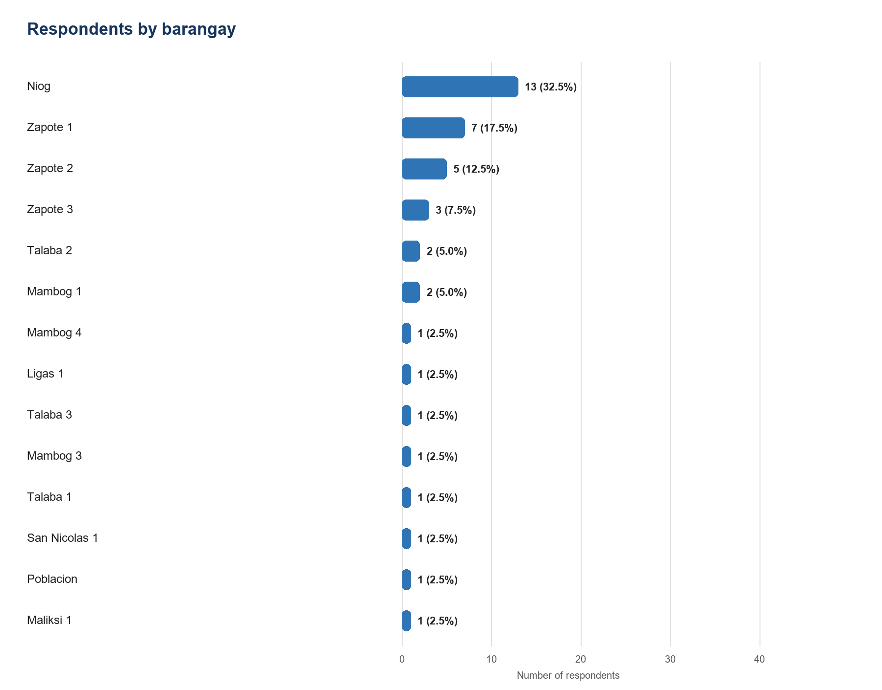
Figure 1. Distribution of respondents by barangay (n = 40).
Barangay | Frequency | Percentage
Niog | 13 | 32.5%
Zapote 1 | 7 | 17.5%
Zapote 2 | 5 | 12.5%
Zapote 3 | 3 | 7.5%
Talaba 2 | 2 | 5.0%
Mambog 1 | 2 | 5.0%
Mambog 4 | 1 | 2.5%
Ligas 1 | 1 | 2.5%
Talaba 3 | 1 | 2.5%
Mambog 3 | 1 | 2.5%
Talaba 1 | 1 | 2.5%
San Nicolas 1 | 1 | 2.5%
Poblacion | 1 | 2.5%
Maliksi 1 | 1 | 2.5%

2.2 Age Distribution
The sample was concentrated among younger adults. The 25-34 group accounted for 17 respondents (42.5%), followed by the 18-24 group with 13 (32.5%).
Age group | Frequency | Percentage
18-24 years old | 13 | 32.5%
25-34 years old | 17 | 42.5%
35-44 years old | 7 | 17.5%
45-54 years old | 2 | 5.0%
55-64 years old | 0 | 0.0%
65 years old or older | 1 | 2.5%

3 Flood and Heavy-Rainfall Experience

3.1 Reported Effects
Respondents reported effects across the household, community, mobility, work or study, evacuation, property, and essential-service dimensions. Because this was a multiple-response question, each percentage represents the share of all 40 respondents selecting the effect.
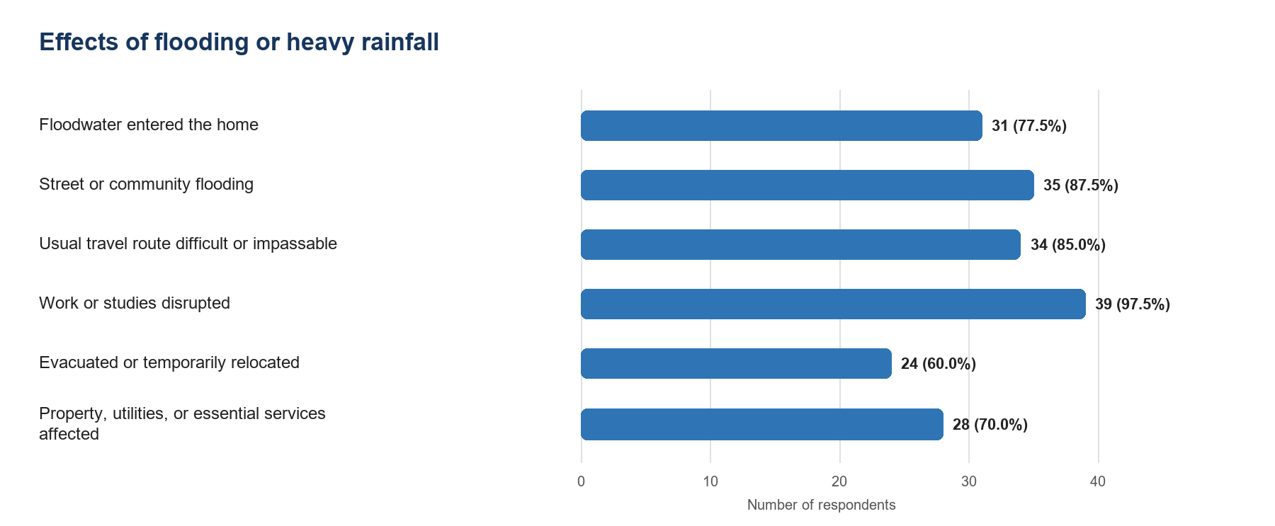
Figure 2. Reported effects of flooding or heavy rainfall (multiple responses, n = 40).
Reported effect | Frequency | Percentage
Floodwater entered the home | 31 | 77.5%
Street or community flooding | 35 | 87.5%
Usual travel route difficult or impassable | 34 | 85.0%
Work or studies disrupted | 39 | 97.5%
Evacuated or temporarily relocated | 24 | 60.0%
Property, utilities, or essential services affected | 28 | 70.0%

3.2 Number of Experienced Events
Thirty respondents (75.0%) reported more than five separate flood or heavy-rainfall events during the three-year reference period. The remaining ten (25.0%) reported two to three events. No respondent selected one event, four to five events, or not sure.
Reported number of events | Frequency | Percentage
1 event | 0 | 0.0%
2-3 events | 10 | 25.0%
4-5 events | 0 | 0.0%
More than 5 events | 30 | 75.0%
Not sure | 0 | 0.0%

4 Existing Flood-Information Sources
Respondents relied on multiple formal and informal channels. The continued use of many sources is important to interpretation: the reported problem is not that residents have no information channel at all, but that available channels do not consistently meet their needs.
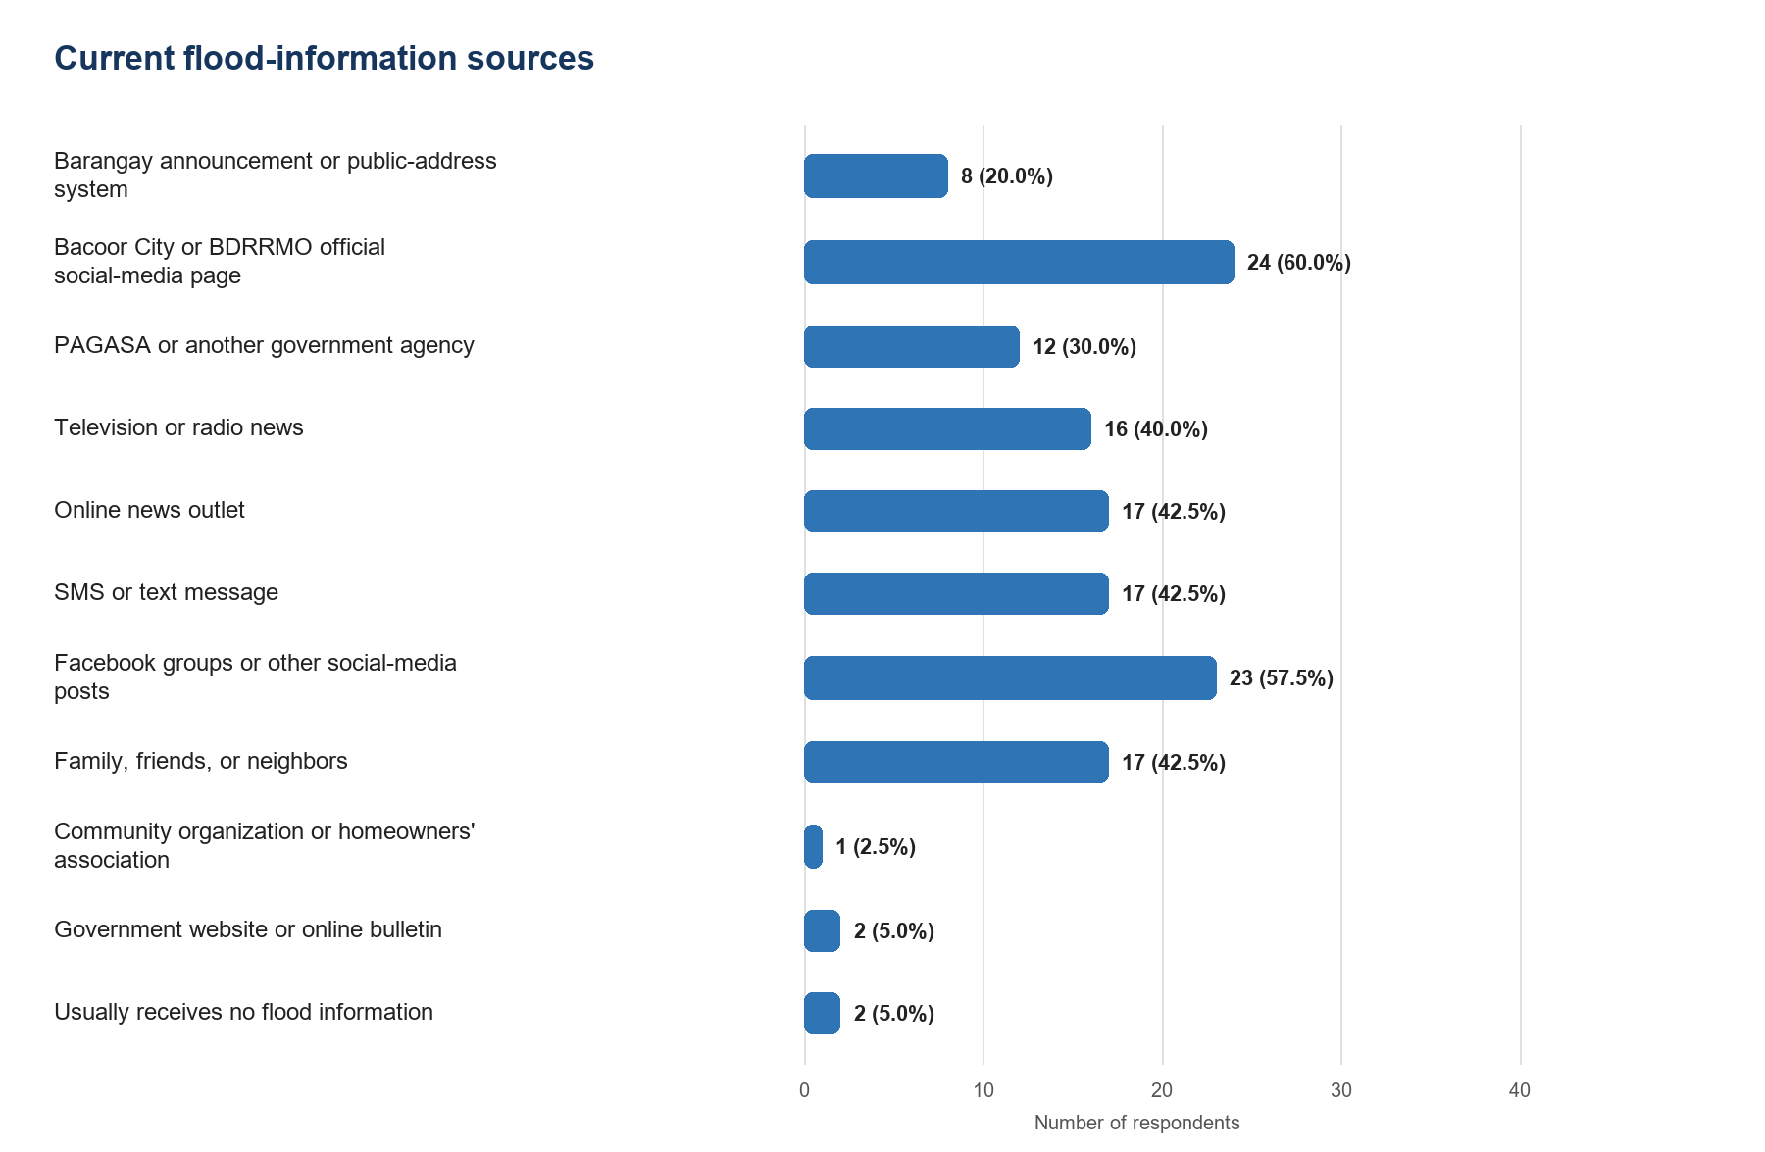
Figure 3. Sources currently used for flood or heavy-rainfall information (multiple responses, n = 40).
Information source | Frequency | Percentage
Barangay announcement or public-address system | 8 | 20.0%
Bacoor City or BDRRMO official social-media page | 24 | 60.0%
PAGASA or another government agency | 12 | 30.0%
Television or radio news | 16 | 40.0%
Online news outlet | 17 | 42.5%
SMS or text message | 17 | 42.5%
Facebook groups or other social-media posts | 23 | 57.5%
Family, friends, or neighbors | 17 | 42.5%
Community organization or homeowners' association | 1 | 2.5%
Government website or online bulletin | 2 | 5.0%
Usually receives no flood information | 2 | 5.0%
One response selected both 'usually receives no flood information' and other sources. This contradiction was retained in the category counts but should not be interpreted as a consistent source-use pattern.

5 Difficulty Obtaining Needed Information
A combined 29 respondents (72.5%) selected difficult, very difficult, or usually cannot obtain the information. Only 6 (15.0%) selected easy or very easy.
Ease of obtaining needed information | Frequency | Percentage
Very easy | 1 | 2.5%
Easy | 5 | 12.5%
Neither easy nor difficult | 5 | 12.5%
Difficult | 10 | 25.0%
Very difficult | 13 | 32.5%
I usually cannot obtain the information | 6 | 15.0%
Not sure | 0 | 0.0%

6 Problems with Existing Flood-Information Sources
Every assessed problem had a mean score in the 'Often' range. The highest mean concerned information that was too general or not location-specific. Other high-ranking problems involved difficulty accessing information when internet or electricity was unreliable, overly general preparedness instructions, unclear sources or dates, and difficulty finding verified evacuation-center information.
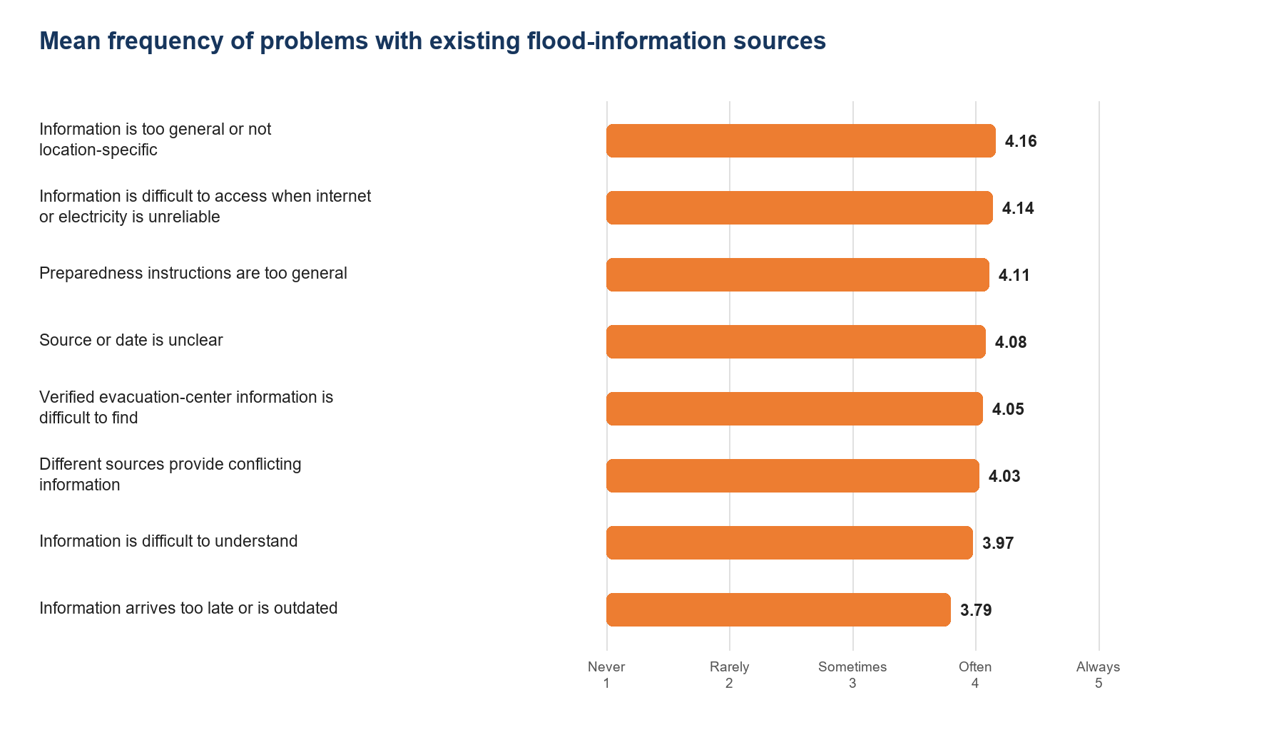
Figure 4. Mean frequency of eight problems with existing information sources. Not-sure responses were excluded from means.
Rank | Problem | Mean | Interpretation | Often or always | Valid n
1 | Information is too general or not location-specific | 4.16 | Often | 29 (72.5%) | 38
2 | Information is difficult to access when internet or electricity is unreliable | 4.14 | Often | 28 (70.0%) | 37
3 | Preparedness instructions are too general | 4.11 | Often | 28 (70.0%) | 37
4 | Source or date is unclear | 4.08 | Often | 28 (70.0%) | 38
5 | Verified evacuation-center information is difficult to find | 4.05 | Often | 29 (72.5%) | 38
6 | Different sources provide conflicting information | 4.03 | Often | 26 (65.0%) | 37
7 | Information is difficult to understand | 3.97 | Often | 30 (75.0%) | 39
8 | Information arrives too late or is outdated | 3.79 | Often | 24 (60.0%) | 39

6.1 Complete Frequency Distribution
Problem | Never | Rarely | Sometimes | Often | Always | Not sure
Information arrives too late or is outdated | 2 | 7 | 6 | 6 | 18 | 1
Information is difficult to understand | 2 | 4 | 3 | 14 | 16 | 1
Information is too general or not location-specific | 2 | 2 | 5 | 8 | 21 | 2
Different sources provide conflicting information | 0 | 7 | 4 | 7 | 19 | 3
Source or date is unclear | 2 | 2 | 6 | 9 | 19 | 2
Information is difficult to access when internet or electricity is unreliable | 1 | 4 | 4 | 8 | 20 | 3
Preparedness instructions are too general | 1 | 7 | 1 | 6 | 22 | 3
Verified evacuation-center information is difficult to find | 3 | 3 | 3 | 9 | 20 | 2

7 Effects on Preparedness and Decision-Making

7.1 Frequency of Decision Effects
Thirty respondents (75.0%) said late, unclear, incomplete, or conflicting information affected their decisions often or always. Only two respondents (5.0%) selected never.
Frequency | Count | Percentage
Never | 2 | 5.0%
Rarely | 4 | 10.0%
Sometimes | 4 | 10.0%
Often | 9 | 22.5%
Always | 21 | 52.5%
Not sure | 0 | 0.0%

7.2 Types of Decisions Affected
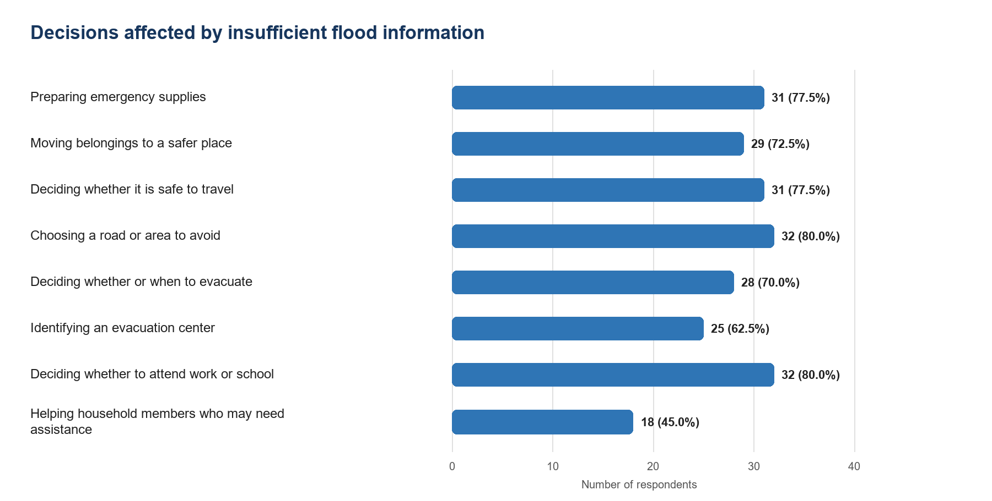
Figure 5. Decisions made difficult, uncertain, or delayed by insufficient flood information (multiple responses, n = 40).
Decision area | Frequency | Percentage
Preparing emergency supplies | 31 | 77.5%
Moving belongings to a safer place | 29 | 72.5%
Deciding whether it is safe to travel | 31 | 77.5%
Choosing a road or area to avoid | 32 | 80.0%
Deciding whether or when to evacuate | 28 | 70.0%
Identifying an evacuation center | 25 | 62.5%
Deciding whether to attend work or school | 32 | 80.0%
Helping household members who may need assistance | 18 | 45.0%
None of the above | 3 | 7.5%
A total of 2 responses selected 'None of the above' together with substantive decision areas. The responses were retained, but the combinations are internally inconsistent.

8 Location-Specific and Evacuation Information

8.1 Determining Location Susceptibility
A total of 30 respondents (75.0%) found it difficult or very difficult to determine whether their barangay or location might be susceptible to flooding, or stated that they did not know how to determine it. This directly supports the need for accessible location-specific susceptibility information.
Difficulty determining susceptibility | Frequency | Percentage
Very easy | 2 | 5.0%
Easy | 3 | 7.5%
Neither easy nor difficult | 5 | 12.5%
Difficult | 10 | 25.0%
Very difficult | 11 | 27.5%
I do not know how to determine it | 9 | 22.5%
Not sure | 0 | 0.0%

8.2 Finding Verified Evacuation-Center Information
A total of 33 respondents (82.5%) found verified evacuation-center information difficult or very difficult to locate, or did not know where to find it.
Ease of finding verified center information | Frequency | Percentage
Very easy | 3 | 7.5%
Easy | 1 | 2.5%
Neither easy nor difficult | 3 | 7.5%
Difficult | 8 | 20.0%
Very difficult | 15 | 37.5%
I do not know where to find it | 10 | 25.0%
I have not needed this information | 0 | 0.0%
Not sure | 0 | 0.0%

8.3 Evacuation-Center Details Considered Useful
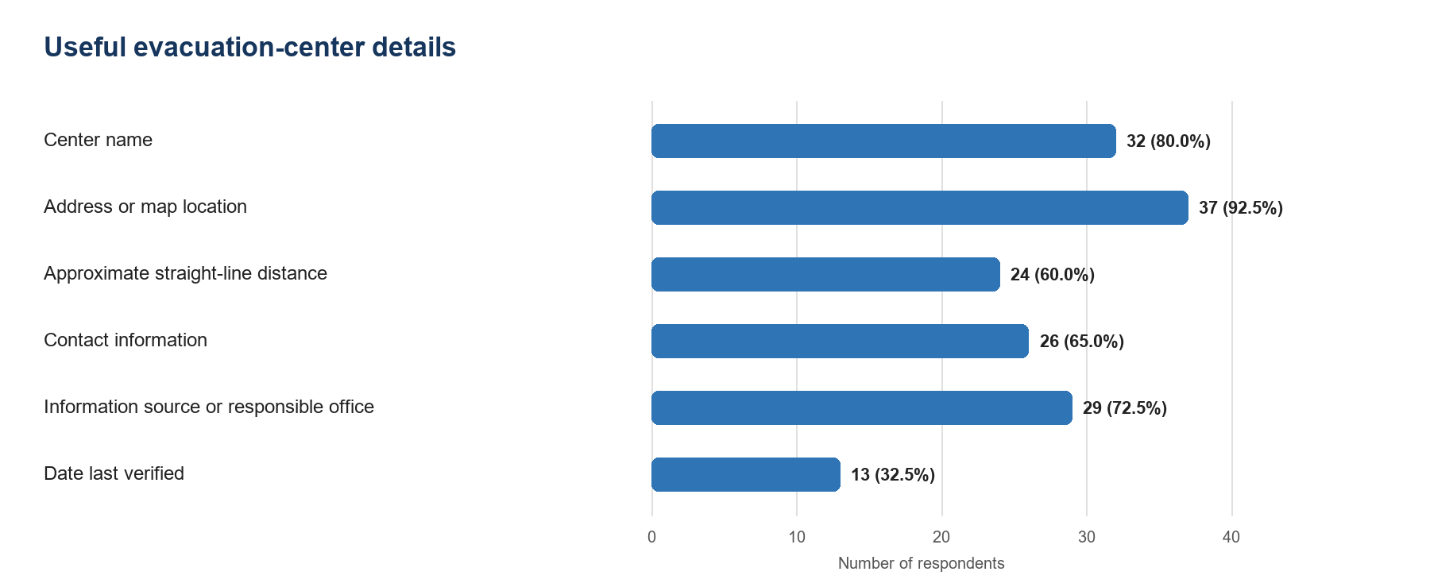
Figure 6. Evacuation-center details considered useful (multiple responses, n = 40).
Evacuation-center detail | Frequency | Percentage
Center name | 32 | 80.0%
Address or map location | 37 | 92.5%
Approximate straight-line distance | 24 | 60.0%
Contact information | 26 | 65.0%
Information source or responsible office | 29 | 72.5%
Date last verified | 13 | 32.5%
Does not need evacuation-center information | 2 | 5.0%
Not sure | 1 | 2.5%
Two respondents selected 'does not need evacuation-center information' together with one or more requested details. These inconsistent selections were retained and disclosed.

9 Priority Information Needs
Respondents selected up to three information types considered most important before possible flooding. The distribution identifies both needs that fit the current FloodSense scope and needs that remain outside it. Current road or travel conditions and real-time or forecast-related information should not be presented as current FloodSense functions unless the research scope and validated data sources are formally expanded.
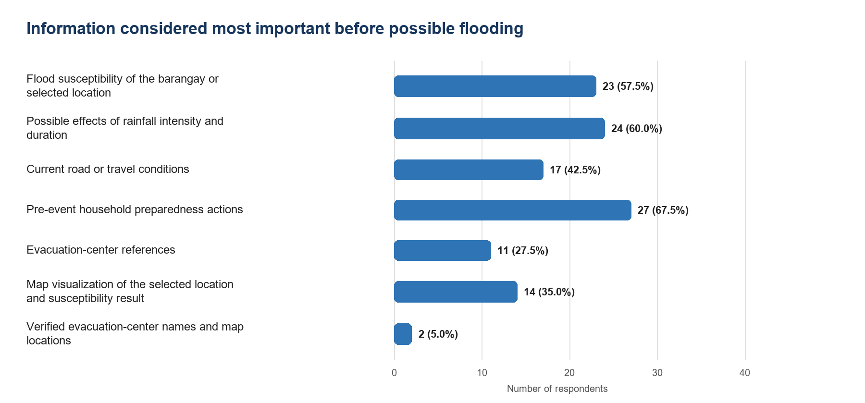
Figure 7. Information considered most important before possible flooding (up to three responses per participant, n = 40).
Information need | Frequency | Percentage
Flood susceptibility of the barangay or selected location | 23 | 57.5%
Possible effects of rainfall intensity and duration | 24 | 60.0%
Current road or travel conditions | 17 | 42.5%
Pre-event household preparedness actions | 27 | 67.5%
Evacuation-center references | 11 | 27.5%
Map visualization of the selected location and susceptibility result | 14 | 35.0%
Verified evacuation-center names and map locations | 2 | 5.0%

10 Problems with Existing Preparedness Guidance
The results indicate that respondents' concerns extend beyond obtaining warnings. Many also reported that existing advice is too general, not specific to their location or situation, difficult to understand or access, unclear in action sequence, or unclear in source. These findings support a need for clearer, sourced, and situation-relevant pre-event guidance.
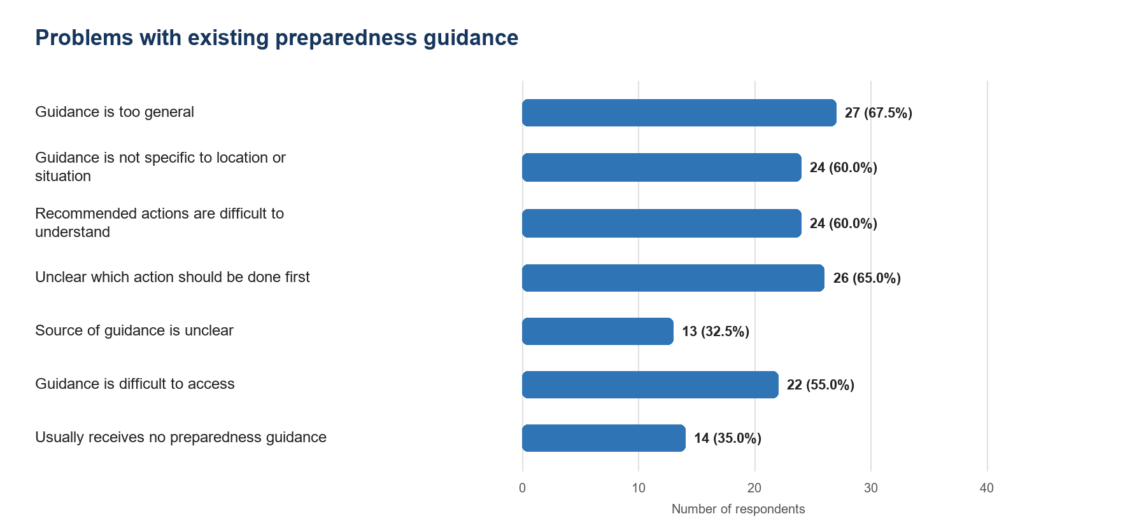
Figure 8. Problems experienced with preparedness guidance from existing sources (multiple responses, n = 40).
Preparedness-guidance response | Frequency | Percentage
Guidance is too general | 27 | 67.5%
Guidance is not specific to location or situation | 24 | 60.0%
Recommended actions are difficult to understand | 24 | 60.0%
Unclear which action should be done first | 26 | 65.0%
Source of guidance is unclear | 13 | 32.5%
Guidance is difficult to access | 22 | 55.0%
Usually receives no preparedness guidance | 14 | 35.0%
No problem experienced with available guidance | 3 | 7.5%
Not sure | 0 | 0.0%
One response selected both 'usually receives no preparedness guidance' and 'no problem experienced.' The contradictory combination was retained in both category counts.

11 Technology, Connectivity, and Presentation Requirements

11.1 Android Access
Regular Android access was reported by 39 respondents (97.5%): 34 had their own device and 5 used a shared device. One respondent was unsure whether the available device used Android.
Android access | Frequency | Percentage
Yes, my own device | 34 | 85.0%
Yes, a shared device | 5 | 12.5%
No | 0 | 0.0%
Not sure whether it is Android | 1 | 2.5%

11.2 Internet Reliability During Heavy Rainfall
Internet access was described as always or usually reliable by 29 respondents (72.5%). However, 11 (27.5%) reported only sometimes or rarely reliable access, indicating a need for efficient data use and clear handling of unavailable information.
Internet reliability | Frequency | Percentage
Always reliable | 13 | 32.5%
Usually reliable | 16 | 40.0%
Sometimes reliable | 6 | 15.0%
Rarely reliable | 5 | 12.5%
No internet access | 0 | 0.0%
Not sure | 0 | 0.0%

11.3 Accepted Location-Selection Methods
Respondents could select more than one method. One-time GPS, a temporary map pin, and manual barangay selection were all accepted by substantial shares of the sample. The results support retaining multiple methods rather than making precise GPS the only way to use location-specific functions.
Location-selection response | Frequency | Percentage
Manual barangay selection | 25 | 62.5%
Temporary map pin without saved location history | 26 | 65.0%
One-time GPS after explanation and permission | 33 | 82.5%
Not comfortable providing or selecting a location | 4 | 10.0%
Not sure | 0 | 0.0%
One response combined location discomfort with accepted location methods. The system should continue to provide a manual option, a clear purpose explanation, and explicit permission before one-time GPS access.

11.4 Language Preference
Bilingual English and Filipino presentation was preferred by 30 respondents (75.0%).
Preferred presentation | Frequency | Percentage
English | 9 | 22.5%
Filipino | 1 | 2.5%
Both English and Filipino | 30 | 75.0%

12 Optional Open-Ended Responses
Twenty-one respondents (52.5%) entered an optional comment. The comments were coded into overlapping themes, so theme percentages can total more than 100%. Names were not used in coding.
Theme | Comments | Percentage of 21 comments
Map, GPS, barangay, or location information | 13 | 61.9%
Real-time conditions, flood timing, or early warning | 9 | 42.9%
Flood depth or severity | 8 | 38.1%
Evacuation-center location or contact information | 3 | 14.3%
Detailed or clearer announcements | 2 | 9.5%
Hazard-map details such as drainage canals or open manholes | 6 | 28.6%
No additional information identified | 2 | 9.5%
The most common ideas concerned maps or location information, real-time conditions or early warning, water depth or severity, and evacuation-center information. Some of these requests exceed the approved scenario-based scope. They should be recorded as resident needs without being represented as existing FloodSense capabilities.
Qualitative caution: six entries used the same long recommendation word for word, two entries consisted of 'none,' and two consisted of 'map.' The repeated long text was counted six times in the frequency table because it appeared in six submitted records, but it represents only one unique wording pattern.

13 Integrated Answers to the Research Concerns

13.1 Is There a Real Flood-Information Problem
Yes, among the surveyed respondents. The evidence includes 29 respondents reporting difficulty or inability to obtain needed information, all eight information-problem indicators falling in the 'Often' mean range, and 30 respondents saying inadequate information often or always affected decisions. This supports the existence of an information-access and decision-support problem within the surveyed group.

13.2 Is an Additional Tool Needed Despite Existing Sources
The data support the need for a supplementary tool, not the replacement of official sources. Respondents already use Bacoor City or BDRRMO pages, PAGASA or other government agencies, news, SMS, Facebook groups, personal networks, and barangay channels. Their simultaneous reports of persistent problems indicate that existing channels do not always provide information in the location-specific, explainable, accessible, and actionable form they need.

13.3 How FloodSense Can Address the Identified Problems
Survey-supported problem or requirement | FloodSense response within current scope
General or non-location-specific information | Barangay selection, temporary map pin, and optional one-time GPS for supported Bacoor locations
Difficulty determining local susceptibility | Scenario-based susceptibility assessment for a selected location
Unclear basis, source, or date | Explainable results with source, status, date, and limitation information
Preparedness instructions too general | Separately sourced pre-event guidance relevant to the assessed scenario
Verified evacuation-center information difficult to find | Verified center references with map location and approximate straight-line distance
Internet reliability varies | Efficient requests, clear unavailable states, and no fabricated result when data cannot be retrieved
Different language preferences | Clear bilingual English and Filipino presentation where feasible
This mapping establishes design relevance. It does not prove that the implemented application is already effective. Actual usefulness, usability, clarity, reliability, and decision-support value must be measured after respondents use the working prototype.

13.4 What the Initial Survey Does Not Prove
- It does not prove the scientific accuracy of the susceptibility method or expert rules.
- It does not validate BDRRMO, CPDCO, PAGASA, geographic, rainfall, water-level, or evacuation-center datasets.
- It does not prove that FloodSense improves preparedness or decision quality after use.
- It does not evaluate actual usability, performance, reliability, security, or ISO 25010 characteristics.
- It does not authorize claims of live forecasting, automatic warnings, road safety, safe routes, center availability, or evacuation orders.

14 Implications for the Statement of the Problem
The survey can support the resident-focused part of the Statement of the Problem by establishing current information challenges, their decision effects, and priority requirements. The final Statement of the Problem should retain separate questions for expert validation, system development and functional testing, and post-use quality evaluation because those matters cannot be answered by this initial survey alone.

14.1 Evidence-Supported Problem Areas
- Access to timely, understandable, consistent, and source-transparent flood information
- Availability of location-specific flood-susceptibility information
- Effects of inadequate information on household preparation, travel, evacuation, work, school, and assistance to vulnerable household members
- Availability of clear and situation-relevant pre-event preparedness guidance
- Availability of verified evacuation-center references and useful facility details
- Feasibility and privacy requirements for Android, connectivity, language, and location selection

14.2 Recommended Evidence Chain
Evidence source | Research contribution
Initial resident survey | Establishes resident problems, decision effects, needs, and access constraints
BDRRMO and CPDCO interviews and records | Validate institutional knowledge, sources, workflows, geographic data, and operational boundaries
Expert and methodology validation | Validate inference rules, parameters, interpretations, and limitations
Functional and technical testing | Confirm that approved functions work as specified
Post-use evaluation | Measure actual usefulness, usability, clarity, acceptability, and relevant ISO 25010 characteristics

15 Conclusions
The 40-response initial survey provides coherent descriptive evidence that the surveyed Bacoor residents experience recurring flood and heavy-rainfall impacts and face substantial problems obtaining information that is timely, clear, consistent, accessible, source-transparent, and specific to their location. These problems frequently affect preparedness and everyday decisions.
The findings support the need for an additional, resident-facing information tool even though respondents already use official pages, government agencies, news, social media, SMS, barangay channels, and personal networks. The defensible justification for FloodSense is therefore its role as a supplementary, scenario-based, pre-event decision-support tool that organizes approved information into location-specific susceptibility results, explanations, preparedness guidance, and verified evacuation-center references.
The survey does not demonstrate that FloodSense has already improved preparedness. That conclusion requires respondents to use the implemented system and complete a separate post-use evaluation. The present findings should be used to define and justify the problem, derive requirements within scope, and guide the later evaluation design.

16 Recommendations
1. Use the findings to revise the resident-focused SOP and objectives, but phrase claims as applying to the surveyed respondents rather than all Bacoor residents.
2. Retain FloodSense as a complement to official information channels and maintain explicit limitations that it is not a live forecast, official warning, evacuation order, route-safety service, or live center-availability system.
3. Prioritize location-specific assessment, explainable results, scenario-relevant preparedness guidance, verified evacuation-center references, privacy-preserving location choices, and bilingual presentation.
4. Validate scientific inputs, geographic data, institutional workflows, and center records through BDRRMO, CPDCO, relevant source documents, and expert review.
5. Conduct a separate post-use evaluation with structured tasks and measures for actual usefulness, clarity, usability, reliability, and relevant ISO 25010 characteristics.
6. For future survey rounds, replace mutually exclusive checkbox combinations with single-choice questions or branching, use a shorter recall period or ask respondents to focus on their most recent event, and use respondent codes if matching initial and post-use responses.
7. Expand geographic coverage if broader Bacoor conclusions are required, especially in barangays absent or underrepresented in this sample.
8. Review the timing cluster, exact duplicate response pair, and repeated open-ended wording before treating every submission as an independent observation in formal inferential analysis.

Appendix A Complete Question-Level Results
This appendix consolidates the frequency and percentage results used throughout the report. Checkbox percentages are based on all 40 respondents and can total more than 100%.

A1 Barangay
Response | Frequency | Percentage
Niog | 13 | 32.5%
Zapote 1 | 7 | 17.5%
Zapote 2 | 5 | 12.5%
Zapote 3 | 3 | 7.5%
Talaba 2 | 2 | 5.0%
Mambog 1 | 2 | 5.0%
Mambog 4 | 1 | 2.5%
Ligas 1 | 1 | 2.5%
Talaba 3 | 1 | 2.5%
Mambog 3 | 1 | 2.5%
Talaba 1 | 1 | 2.5%
San Nicolas 1 | 1 | 2.5%
Poblacion | 1 | 2.5%
Maliksi 1 | 1 | 2.5%

A2 Age group
Response | Frequency | Percentage
18-24 years old | 13 | 32.5%
25-34 years old | 17 | 42.5%
35-44 years old | 7 | 17.5%
45-54 years old | 2 | 5.0%
55-64 years old | 0 | 0.0%
65 years old or older | 1 | 2.5%

A3 Flood and heavy-rainfall effects
Response | Frequency | Percentage
Floodwater entered the home | 31 | 77.5%
Street or community flooding | 35 | 87.5%
Usual travel route difficult or impassable | 34 | 85.0%
Work or studies disrupted | 39 | 97.5%
Evacuated or temporarily relocated | 24 | 60.0%
Property, utilities, or essential services affected | 28 | 70.0%

A4 Number of experienced events
Response | Frequency | Percentage
1 event | 0 | 0.0%
2-3 events | 10 | 25.0%
4-5 events | 0 | 0.0%
More than 5 events | 30 | 75.0%
Not sure | 0 | 0.0%

A5 Current information sources
Response | Frequency | Percentage
Barangay announcement or public-address system | 8 | 20.0%
Bacoor City or BDRRMO official social-media page | 24 | 60.0%
PAGASA or another government agency | 12 | 30.0%
Television or radio news | 16 | 40.0%
Online news outlet | 17 | 42.5%
SMS or text message | 17 | 42.5%
Facebook groups or other social-media posts | 23 | 57.5%
Family, friends, or neighbors | 17 | 42.5%
Community organization or homeowners' association | 1 | 2.5%
Government website or online bulletin | 2 | 5.0%
Usually receives no flood information | 2 | 5.0%

A6 Ease of obtaining needed information
Response | Frequency | Percentage
Very easy | 1 | 2.5%
Easy | 5 | 12.5%
Neither easy nor difficult | 5 | 12.5%
Difficult | 10 | 25.0%
Very difficult | 13 | 32.5%
I usually cannot obtain the information | 6 | 15.0%
Not sure | 0 | 0.0%

A7 Decisions affected
Response | Frequency | Percentage
Preparing emergency supplies | 31 | 77.5%
Moving belongings to a safer place | 29 | 72.5%
Deciding whether it is safe to travel | 31 | 77.5%
Choosing a road or area to avoid | 32 | 80.0%
Deciding whether or when to evacuate | 28 | 70.0%
Identifying an evacuation center | 25 | 62.5%
Deciding whether to attend work or school | 32 | 80.0%
Helping household members who may need assistance | 18 | 45.0%
None of the above | 3 | 7.5%

A8 Difficulty determining location susceptibility
Response | Frequency | Percentage
Very easy | 2 | 5.0%
Easy | 3 | 7.5%
Neither easy nor difficult | 5 | 12.5%
Difficult | 10 | 25.0%
Very difficult | 11 | 27.5%
I do not know how to determine it | 9 | 22.5%
Not sure | 0 | 0.0%

A9 Ease of finding verified evacuation-center information
Response | Frequency | Percentage
Very easy | 3 | 7.5%
Easy | 1 | 2.5%
Neither easy nor difficult | 3 | 7.5%
Difficult | 8 | 20.0%
Very difficult | 15 | 37.5%
I do not know where to find it | 10 | 25.0%
I have not needed this information | 0 | 0.0%
Not sure | 0 | 0.0%

A10 Priority information needs
Response | Frequency | Percentage
Flood susceptibility of the barangay or selected location | 23 | 57.5%
Possible effects of rainfall intensity and duration | 24 | 60.0%
Current road or travel conditions | 17 | 42.5%
Pre-event household preparedness actions | 27 | 67.5%
Evacuation-center references | 11 | 27.5%
Map visualization of the selected location and susceptibility result | 14 | 35.0%
Verified evacuation-center names and map locations | 2 | 5.0%

A11 Problems with preparedness guidance
Response | Frequency | Percentage
Guidance is too general | 27 | 67.5%
Guidance is not specific to location or situation | 24 | 60.0%
Recommended actions are difficult to understand | 24 | 60.0%
Unclear which action should be done first | 26 | 65.0%
Source of guidance is unclear | 13 | 32.5%
Guidance is difficult to access | 22 | 55.0%
Usually receives no preparedness guidance | 14 | 35.0%
No problem experienced with available guidance | 3 | 7.5%
Not sure | 0 | 0.0%

A12 Useful evacuation-center details
Response | Frequency | Percentage
Center name | 32 | 80.0%
Address or map location | 37 | 92.5%
Approximate straight-line distance | 24 | 60.0%
Contact information | 26 | 65.0%
Information source or responsible office | 29 | 72.5%
Date last verified | 13 | 32.5%
Does not need evacuation-center information | 2 | 5.0%
Not sure | 1 | 2.5%

A13 Android access
Response | Frequency | Percentage
Yes, my own device | 34 | 85.0%
Yes, a shared device | 5 | 12.5%
No | 0 | 0.0%
Not sure whether it is Android | 1 | 2.5%

A14 Internet reliability
Response | Frequency | Percentage
Always reliable | 13 | 32.5%
Usually reliable | 16 | 40.0%
Sometimes reliable | 6 | 15.0%
Rarely reliable | 5 | 12.5%
No internet access | 0 | 0.0%
Not sure | 0 | 0.0%

A15 Accepted location-selection methods
Response | Frequency | Percentage
Manual barangay selection | 25 | 62.5%
Temporary map pin without saved location history | 26 | 65.0%
One-time GPS after explanation and permission | 33 | 82.5%
Not comfortable providing or selecting a location | 4 | 10.0%
Not sure | 0 | 0.0%

A16 Language preference
Response | Frequency | Percentage
English | 9 | 22.5%
Filipino | 1 | 2.5%
Both English and Filipino | 30 | 75.0%

Appendix B Complete Information-Problem Matrix

Information arrives too late or is outdated
Response | Frequency | Percentage or interpretation
Never | 2 | 5.0%
Rarely | 7 | 17.5%
Sometimes | 6 | 15.0%
Often | 6 | 15.0%
Always | 18 | 45.0%
Not sure | 1 | 2.5%
Weighted mean excluding Not sure | 3.79 | Often

Information is difficult to understand
Response | Frequency | Percentage or interpretation
Never | 2 | 5.0%
Rarely | 4 | 10.0%
Sometimes | 3 | 7.5%
Often | 14 | 35.0%
Always | 16 | 40.0%
Not sure | 1 | 2.5%
Weighted mean excluding Not sure | 3.97 | Often

Information is too general or not location-specific
Response | Frequency | Percentage or interpretation
Never | 2 | 5.0%
Rarely | 2 | 5.0%
Sometimes | 5 | 12.5%
Often | 8 | 20.0%
Always | 21 | 52.5%
Not sure | 2 | 5.0%
Weighted mean excluding Not sure | 4.16 | Often

Different sources provide conflicting information
Response | Frequency | Percentage or interpretation
Never | 0 | 0.0%
Rarely | 7 | 17.5%
Sometimes | 4 | 10.0%
Often | 7 | 17.5%
Always | 19 | 47.5%
Not sure | 3 | 7.5%
Weighted mean excluding Not sure | 4.03 | Often

Source or date is unclear
Response | Frequency | Percentage or interpretation
Never | 2 | 5.0%
Rarely | 2 | 5.0%
Sometimes | 6 | 15.0%
Often | 9 | 22.5%
Always | 19 | 47.5%
Not sure | 2 | 5.0%
Weighted mean excluding Not sure | 4.08 | Often

Information is difficult to access when internet or electricity is unreliable
Response | Frequency | Percentage or interpretation
Never | 1 | 2.5%
Rarely | 4 | 10.0%
Sometimes | 4 | 10.0%
Often | 8 | 20.0%
Always | 20 | 50.0%
Not sure | 3 | 7.5%
Weighted mean excluding Not sure | 4.14 | Often

Preparedness instructions are too general
Response | Frequency | Percentage or interpretation
Never | 1 | 2.5%
Rarely | 7 | 17.5%
Sometimes | 1 | 2.5%
Often | 6 | 15.0%
Always | 22 | 55.0%
Not sure | 3 | 7.5%
Weighted mean excluding Not sure | 4.11 | Often

Verified evacuation-center information is difficult to find
Response | Frequency | Percentage or interpretation
Never | 3 | 7.5%
Rarely | 3 | 7.5%
Sometimes | 3 | 7.5%
Often | 9 | 22.5%
Always | 20 | 50.0%
Not sure | 2 | 5.0%
Weighted mean excluding Not sure | 4.05 | Often

Appendix C Source and Analysis Notes
Source: FloodSense Resident Survey Questionnaire response workbook, worksheet 'Form responses 2,' containing 40 submissions and 32 columns. The workbook was analyzed without modifying the source file.
Percentages were calculated as frequency divided by 40 unless another denominator is stated. Values may differ from 100.0% by 0.1 percentage point because of rounding. Open-ended themes overlap and use the 21 nonblank comments as their denominator.
No respondent name or initials are reproduced. Optional comments were used only for theme coding and data-quality review.

